“***Creating of Culture of Excellence***”

# Assignment - 2

## **Course Title :** System Analysis & Design

## **Course Code :** CSE- 325

## **Assignment Name :** ATM Matching Activity Diagram.

## Submitted By:

### ID : 171442552

### Name : Md. Harun Or Rashid

### Program : CSE(Eve)

### Batch : 44th

### Date : 29-06-2019

## Submitted To:

### Supta Richard Philip

### Senior Lecturer, Department of CSE

### City University, Bangladesh

Contents

Assignment - 2 1

**Course Title**  **:** System Analysis & Design 1

**Course Code**  **:** CSE- 325 1

**Assignment Name :** ATM Matching Activity Diagram. 1

Submitted By: 1

ID : 171442552 1

Name : Md. Harun Or Rashid 1

Program : CSE(Eve) 1

Batch : 44th 1

Date : 29-06-2019 1

Submitted To: 1

Supta Richard Philip 1

Senior Lecturer, Department of CSE 1

City University, Bangladesh 1

Activity Diagram 3

Activity Diagrams Guidelines 3

ATM Matching Activity Diagram. 4

THE END 4

### Activity Diagram

Activity Diagrams consist of activities, states and transitions between activities and states. Activity Diagrams describe how activities are coordinated to provide a service. You can use activity diagram to model the logic of a single use case, or even how to coordinate a collection of use cases for the entire targeted system being developed. For example, to model how the events in a single use case relate to one another - in particular, use cases where activities may overlap and require coordination.

### Activity Diagrams Guidelines

Minimize the number of crossings links or relationship among activities.

Reorganize larger diagrams into several smaller ones. It is often easier to have several diagrams on various levels of detail than a single complex one.

Use swimlanes to model responsibility of stakeholders, function of department or service provided by operational units.

It can be used to elaborate the logic of an entity in UML, such as, a use case, function or orchestration of several use cases and etc.

# ATM Matching Activity Diagram.

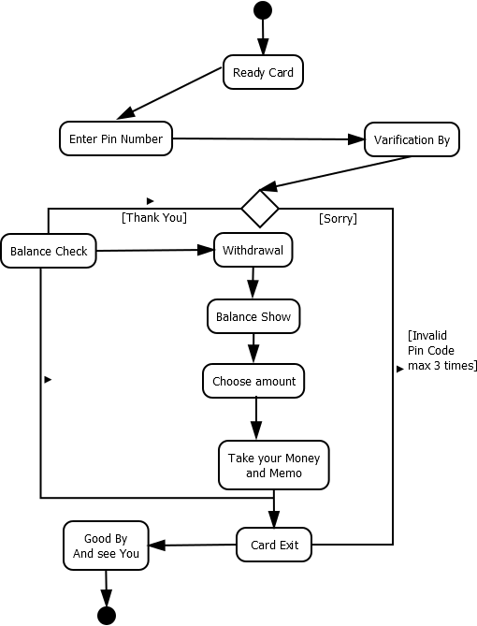

# THE END